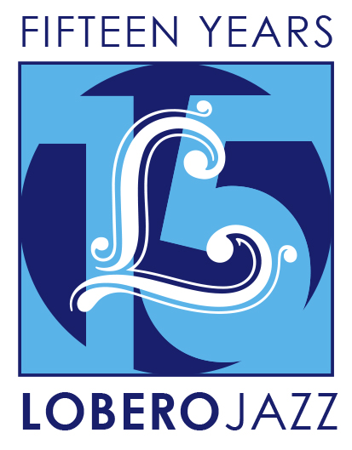
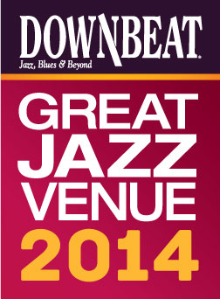

FOR IMMEDIATE RELEASE

Press Contact: Angie Bertucci 805.679.6010 abertucci@lobero.com
Tickets: Lobero Box Office
805.963.0761 or lobero.com

Jazz at the Lobero presents
New Orleans Legends:
Preservation Hall Jazz Band with Allen Toussaint

- Tuesday, November 25 at 8 PM at the Lobero Theatre
- Preservation Hall Jazz Band represents over 50 years of traditional New Orleans Jazz
- Pianist Allen Toussaint is one of the most influential figures in New Orleans R&B

Santa Barbara, CA, October 14, 2014 – Jazz at the Lobero is thrilled to present two of New Orleans’ best-known musical treasures. R&B legend Allen Toussaint joins traditional jazz giants the Preservation Hall Jazz Band as the Crescent City holds sway at the Lobero Theatre for an unforgettable evening. Get ready for a deep dive into New Orleans’ vibrant musical heritage. The ebullient Preservation Hall Jazz Band has kept traditional jazz alive in the French Quarter for a half-century, and Allen Toussaint is one of the most influential figures in contemporary New Orleans music. He is a member of the Rock and Roll Hall of Fame, a multiple GRAMMY® nominee, and, like Preservation Hall, a National Medal of Arts recipient.

Preservation Hall Jazz Band
From the heart of the French Quarter to the world’s stage, the Preservation Hall Jazz Band has spread the joyful, timeless spirit of true New Orleans jazz since 1961. At the band’s 50th anniversary celebration at Carnegie Hall, audiences reveled in “the polyphonic glories of vintage New Orleans jazz, in which nearly every instrument seems to improvise around the tune at the same time” (New York Times).
“Return to the roots of jazz, America's great indigenous art form, and don't miss an opportunity for a performance by the ‘best jazz band in the land.’” – San Francisco Examiner

Allen Toussaint
Allen Toussaint is part of New Orleans music royalty – a renowned songwriter, producer, arranger, and performer celebrated for his distinctive deft and funky feel on the piano that earned him a spot in the Rock and Roll Hall of Fame. With a poet’s ear for lyrics and songwriting steeped in New Orleans street music, countless artists in an array of styles have covered Toussaint’s hit-making R&B songs.

"When I meet someone like Allen Toussaint – that for me is like meeting the equivalent of the Dalai Lama, because he influenced the way I played the piano. He’s a historical part of rock-and-roll.” – Elton John

Tickets for New Orleans Legends: Preservation Hall Jazz Band with Allen Toussaint are on sale now at Lobero.com. Section A tickets are $50 / Section B $45, with a limited number of VIP Tickets available for $105. VIP tickets include pre-show reception and tax-deductible donation to the Lobero Theatre Foundation. All prices include facility fee.

Jazz at the Lobero
Jazz at the Lobero is celebrating 15 big years bringing jazz giants and fans together like nowhere else with an unprecedented two-part jazz series. The fall series concludes with the New Orleans Legends: the Preservation Hall Jazz Band with Allen Toussaint (Nov 25), but will return in the spring with a new three-part series. Subscribers will be the first to hear the spring lineup.

DownBeat Magazine calls the Lobero Theatre, “a jewel of a jazz room,” and recognizes the Lobero in their prestigious guide to the worlds’ Great Jazz Venues each year. Jazz artists have been performing at the Lobero since 1949, building a dynamic legacy that continues today as the Lobero Theatre Foundation works tirelessly to present and preserve this American art form.

Created with the blessing of the late Dave Brubeck himself, the Lobero Brubeck Circle makes it possible for the Lobero to bring amazing jazz, blues and roots artists like Wayne Shorter, Dr. John, Chris Thile, Robert Cray, and Keb’ Mo’ to the Lobero stage. This core group of donors also supports efforts to create the jazz audiences and fans of tomorrow through educational outreach programs. Learn more about the Lobero Brubeck Circle at Lobero.com/Jazz and become a member by designating a gift of $100 or more at Lobero.com/Donate.

# # #

Calendar Editors, please note:
Tuesday, November 25 at 8 p.m.
Lobero Theatre

Jazz at the Lobero presents
New Orleans Legends: Preservation Hall Jazz Band with Allen Toussaint
This meeting of New Orleans’ best-known musical treasures pairs R&B legend Allen Toussaint with traditional jazz giants The Preservation Hall Jazz Band as the Crescent City holds sway at the Lobero Theatre for an unforgettable evening. http://www.lobero.com/events/jazz-new-orleans-legends/

Single Tickets: $50 Section A, $40 Section B, and a limited number of VIP for $105. Prices include facility fee.

Lobero Box Office: www.Lobero.com, 805.963.0761, 33 East Canon Perdido Street, Santa Barbara, CA 93101

Lobero LIVE is sponsored by the Santa Barbara County Arts Commission, the Santa Barbara Independent and KCSB 91.9 FM. Lobero LIVE is funded in part by the Events and Festivals Program using funds provided by the City of Santa Barbara in partnership with the Santa Barbara County Arts Commission. Sponsorship for Jazz at the Lobero is provided by the Lobero Theatre Endowment for American Roots Music, CASA Magazine, Deckers Outdoor Corporation and the Lobero Brubeck Circle of Donors.

