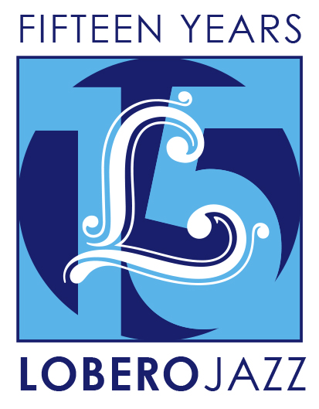
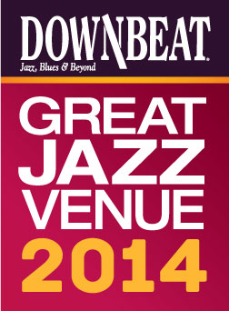

FOR IMMEDIATE RELEASE

Press Contact: Angie Bertucci 805.679.6010 abertucci@lobero.com
Tickets: Lobero Box Office
805.963.0761 or lobero.com

Jazz at the Lobero presents the
Joshua Redman Trio
with Reuben Rogers and Gregory Hutchinson

Jazz at the Lobero Fall Series:
- Joshua Redman Trio with Reuben Rogers and Gregory Hutchinson - Tuesday, September 30
- Dorado Schmitt and the Django Festival All-Stars - Tuesday, November 11
- New Orleans Legends: Preservation Hall Jazz Band with Allen Toussaint - Tuesday, November 25
- Fall Series Tickets on sale now, Single Tickets on sale Thursday, September 4

Santa Barbara, CA, September 2, 2014 – Jazz at the Lobero is thrilled to present the Joshua Redman Trio with Reuben Rogers and Gregory Hutchinson on September 30 to kick of the Fall Jazz series. The GRAMMY®-nominated saxophonist is one of the most esteemed and charismatic artists of his generation. His music can be challenging, provocative, and forward thinking, but also hard-swinging, melodic, and soulful, linking to the jazz idioms of the 1950’s and 60’s with ease. He and his band, long-time collaborators Reuben Rogers on bass and Gregory Hutchinson on drums, demand serious energy and engagement of themselves and their listeners, and create music with a joyous and celebratory spirit. This trio is featured on Redman’s new CD, Trios Live.

“Unparalleled among horn players today.” – JazzTimes

“…carrying on the great tradition of jazz musicianship today.” – JamBase

Jazz at the Lobero is celebrating 15 big years bringing jazz giants and fans together like nowhere else with an unprecedented two-part jazz series. The fall series continues after Redman with gypsy jazz genius Dorado Schmitt and the Django Festival All Stars (Nov 11), and New Orleans Legends: the Preservation Hall Jazz Band with Allen Toussaint. (Nov 25). It’s a fun series from beginning to end celebrating the depth and diversity of the genre. In the spring we’ll offer three more jazz artists at the top of their craft.

Jazz at the Lobero Series subscribers enjoy the best seats and the best prices and are the first to know about new events. Jazz VIP ticketholders can also look forward to exclusive receptions with complimentary appetizers and cocktails before each performance. Jazz at the Lobero Fall Series Tickets are on sale now at Lobero.com, or by calling the Lobero Box Office at 805.963.0761. Series prices are $315 (VIP), $123 (Sec A), $99 (Sec B).

Single tickets for the Joshua Redman Trio will be available on Thursday, September 4. Single ticket prices are $105 (VIP), $45 (Sec A), and $35 (Sec B).

DownBeat Magazine calls the Lobero Theatre, “a jewel of a jazz room,” and recognizes the Lobero in their prestigious guide to the worlds’ Great Jazz Venues each year. Jazz artists have been performing at the Lobero since 1949, building a dynamic legacy that continues today as the Lobero Theatre Foundation works tirelessly to present and preserve this American art form.

Created with the blessing of the late Dave Brubeck himself, the Lobero Brubeck Circle makes it possible for the Lobero to bring amazing jazz, blues and roots artists like Wayne Shorter, Dr. John, Chris Thile, Robert Cray, and Keb’ Mo’ to the Lobero stage over the years. This core group of donors also supports efforts to create the jazz audiences and fans of tomorrow through educational outreach programs. Learn more about the Lobero Brubeck Circle at Lobero.com/Jazz and become a member by designating a gift of $100 or more at Lobero.com/Donate.

Joshua Redman
Saxophonist Joshua Redman is one of the most acclaimed and charismatic jazz artists to have emerged in the decade of the 1990’s. Born in Berkeley, California, he is the son of legendary saxophonist Dewey Redman and dancer Renee Shedroff. Joshua Redman has been nominated for two GRAMMY® awards and has garnered top honors in critics and readers polls of DownBeat, Jazz Times, The Village Voice and Rolling Stone. In addition to his own projects, Redman has recorded and performed with musicians such as Ray Brown, Dave Brubeck, Chick Corea, The Dave Matthews Band, Bill Frisell, Herbie Hancock, Roy Hargrove, Quincy Jones, B.B. King, The Lincoln Center Jazz Orchestra, Joe Lovano, Yo Yo Ma, Branford Marsalis, Dianne Reeves, The Rolling Stones, McCoy Tyner and Stevie Wonder. The trio will be comprised of Mr. Redman, Reuben Rogers on bass and Gregory Hutchinson on drums.
Calendar Editors, please note:
Tuesday, September 30 at 8 p.m.
Lobero Theatre

Jazz at the Lobero presents
Joshua Redman Trio with Reuben Rogers and Gregory Hutchinson
“When conversation ensues about who is carrying on the great tradition of jazz musicianship today, if Joshua Redman’s name does not come up, the conversation is not worth having.” – JamBase http://www.lobero.com/events/jazz-joshua-redman-trio/

Single Tickets: $45 Section A, $35 Section B, and a limited number of VIP for $105 on sale Thursday, September 4. Prices include facility fee.

Lobero Box Office: www.Lobero.com, 805.963.0761, 33 East Canon Perdido Street, Santa Barbara, CA 93101

# # #

Upcoming Jazz at the Lobero Events:

Dorado Schmitt and the Django Festival All-Stars
Tuesday, November 11
No one has done more to ignite interest in the legacy of gypsy jazz guitar pioneer Django Reinhardt than dazzling French guitarist and violinist Dorado Schmitt. For this engagement, Schmitt’s all-star ensemble celebrates the 15th anniversary of the Django Reinhardt Festival in the U.S.

"Mr. Schmitt has the springy phrasing and effusive flow of a Djangoloist; he’s clearly born to the style."
– The New York Times

New Orleans Legends: Preservation Hall Jazz Band with Allen Toussaint
Tuesday, November 25
This meeting of New Orleans’ best-known musical treasures pairs R&B legend Allen Toussaint with traditional jazz giants The Preservation Hall Jazz Band as the Crescent City holds sway at the Lobero Theatre for an unforgettable evening.

"Don't miss an opportunity for a performance by the ‘best jazz band in the land.’” – San Francisco Examiner

Lobero LIVE is sponsored by the Santa Barbara County Arts Commission, the Santa Barbara Independent and KCSB 91.9 FM. Lobero LIVE is funded in part by the Events and Festivals Program using funds provided by the City of Santa Barbara in partnership with the Santa Barbara County Arts Commission. Sponsorship for Jazz at the Lobero is provided by the Lobero Theatre Endowment for American Roots Music, CASA Magazine, Deckers Outdoor Corporation and the Lobero Brubeck Circle of Donors.

