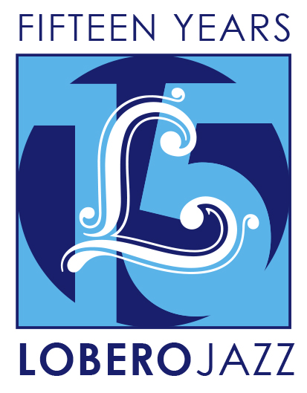
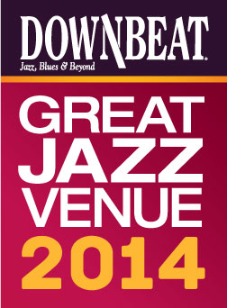

FOR IMMEDIATE RELEASE

Press Contact: Angie Bertucci 805.679.6010 abertucci@lobero.com
Tickets: Lobero Box Office
805.963.0761 or lobero.com

Jazz at the Lobero presents
Dorado Schmitt and the Django Festival All-Stars

- Tuesday, November 11 at 8 PM at the Lobero Theatre
- French guitarist/violinist Dorado Schmitt leads a quintet of Gypsy jazz aficionados
- Celebrating 15 Years of the Django Reinhardt Festival in the United States

Santa Barbara, CA, September 26, 2014 – Jazz at the Lobero is thrilled to present an evening of Gypsy jazz on November 11 with dazzling French guitarist Dorado Schmitt as he leads a stellar band of Django Reinhardt Festival alumni modeled after the Hot Club of France. For this engagement, Schmitt’s all-star ensemble celebrates the 15th anniversary of the Django Reinhardt Festival in the U.S., which counts Leonardo DiCaprio and George Benson as devoted fans.

"Mr. Schmitt has the springy phrasing and effusive flow of a Djangoloist; he’s clearly born to the style. "
— The New York Times

"…The equivalent of a master class in Gypsy jazz. " — The Washington Post

Tickets for Dorado Schmitt & the Django Festival All-Stars are on sale now at Lobero.com. Section A tickets are $45 / Section B $35, with a limited number of VIP Tickets available for $105. VIP tickets include pre-show reception and tax-deductible donation to the Lobero Theatre Foundation. All prices include facility fee.

Dorado Schmitt and the Django Festival All-Stars
No one has done more to ignite interest in the legacy of Gypsy jazz guitar pioneer Django Reinhardt than French guitarist and violinist Dorado Schmitt. Reinhardt lamented that he might be neglected by history, but today the ebulliently swinging sound he created with violinist Stéphane Grappelli in their most famous group, the Quintette du Hot Club de France (Hot Club of France), is more pervasive than ever.

Born to Gypsy parents near the German border in Lorraine, Dorado Schmitt was weaned on traditional Roma music and Gypsy jazz, but rebelled as a teenager by taking up electric guitar and emulating Jimi Hendrix and Carlos Santana. By the mid-90’s he was a leading figure on the international Gypsy jazz scene, where he continues to represent the art form at its highest level.

Joining Dorado Schmitt (guitar & violin) are Samson Schmitt (lead guitar) and DouDou Cuillerier (rhythm guitar and scat vocals), Pierre Blanchard (violin), Ludovic Beier (button accordion) and Brian Torff (bass), with the occasional addition of guest pianist, Peter Beets.

Jazz at the Lobero
Jazz at the Lobero is celebrating 15 big years bringing jazz giants and fans together like nowhere else with an unprecedented two-part jazz series. The fall series continues with Gypsy jazz genius Dorado Schmitt and the Django Festival All Stars (Nov 11), and New Orleans Legends: the Preservation Hall Jazz Band with Allen Toussaint. (Nov 25). It’s a fun series from beginning to end celebrating the depth and diversity of the genre. In the spring we’ll offer three more jazz artists at the top of their craft.

DownBeat Magazine calls the Lobero Theatre, “a jewel of a jazz room,” and recognizes the Lobero in their prestigious guide to the worlds’ Great Jazz Venues each year. Jazz artists have been performing at the Lobero since 1949, building a dynamic legacy that continues today as the Lobero Theatre Foundation works tirelessly to present and preserve this American art form.

Created with the blessing of the late Dave Brubeck himself, the Lobero Brubeck Circle makes it possible for the Lobero to bring amazing jazz, blues and roots artists like Wayne Shorter, Dr. John, Chris Thile, Robert Cray, and Keb’ Mo’ to the Lobero stage. This core group of donors also supports efforts to create the jazz audiences and fans of tomorrow through educational outreach programs. Learn more about the Lobero Brubeck Circle at Lobero.com/Jazz and become a member by designating a gift of $100 or more at Lobero.com/Donate.

# # #
Calendar Editors, please note:
Tuesday, November 11 at 8 p.m.
Lobero Theatre

Jazz at the Lobero presents
Dorado Schmitt & the Django Festival All-Stars
Direct from France, Gypsy jazz genius Dorado Schmitt celebrates 15 years of the Django Reinhardt Festival with an all-star ensemble. http://www.lobero.com/events/jazz-dorado-schmitt-django-festival-stars/

Single Tickets: $45 Section A, $35 Section B, and a limited number of VIP for $105. Prices include facility fee.

Lobero Box Office: www.Lobero.com, 805.963.0761, 33 East Canon Perdido Street, Santa Barbara, CA 93101

UPCOMING JAZZ AT THE LOBERO EVENTS:

New Orleans Legends: Preservation Hall Jazz Band with Allen Toussaint
Tuesday, November 25
This meeting of New Orleans’ best-known musical treasures pairs R&B legend Allen Toussaint with traditional jazz giants The Preservation Hall Jazz Band as the Crescent City holds sway at the Lobero Theatre for an unforgettable evening.

Lobero LIVE is sponsored by the Santa Barbara County Arts Commission, the Santa Barbara Independent and KCSB 91.9 FM. Lobero LIVE is funded in part by the Events and Festivals Program using funds provided by the City of Santa Barbara in partnership with the Santa Barbara County Arts Commission. Sponsorship for Jazz at the Lobero is provided by the Lobero Theatre Endowment for American Roots Music, CASA Magazine, Deckers Outdoor Corporation and the Lobero Brubeck Circle of Donors.

