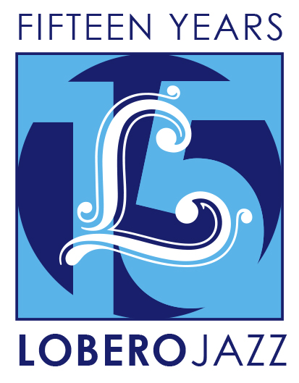
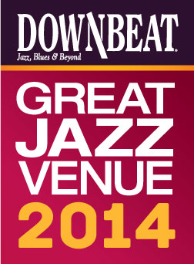

For Immediate Release

Press Contact: Angie Bertucci 805.679.6010 abertucci@lobero.com
Tickets: Lobero Box Office
805.963.0761 or lobero.com

Jazz at the Lobero Celebrates 15 Years with Two-Part Series

Jazz at the Lobero Fall Series:
- Joshua Redman Trio with Reuben Rogers and Gregory Hutchinson - Tuesday, September 30
- Dorado Schmitt and the Django Festival All-Stars - Tuesday, November 11
- New Orleans Legends: Preservation Hall Jazz Band with Allen Toussaint - Tuesday, November 25
- Fall Series Tickets on sale now, Single Tickets on sale September 4
- Details on Spring Series To Be Announced

Santa Barbara, CA, August 11, 2014 – Jazz at the Lobero has been bringing jazz giants and fans together like nowhere else since its inception in 2000. This year we’re celebrating 15 big years with an unprecedented two-part jazz series. To celebrate this milestone, Jazz at the Lobero will be presenting TWO big series this season.

This fall, get ready for the Joshua Redman Trio (Sept 30), followed by an evening with gypsy jazz genius Dorado Schmitt and the Django Festival All Stars (Nov 11), and New Orleans Legends the Preservation Hall Jazz Band with Allen Toussaint. (Nov 25). It’s a fun series from beginning to end celebrating the depth and diversity of the genre. Then, in the spring we’ll offer three more jazz artists at the top of their craft.

From its incredible inaugural season that featured Chick Corea, Wynton Marsalis, Wayne Shorter and Herbie Hancock on through groundbreaking performances by the Spring Quartet featuring Jack DeJohnette and Esperanza Spalding last year, Jazz at the Lobero has provided its share of memorable musical moments.

Series subscribers enjoy the best seats and the best prices and are the first to know about new events. Jazz VIP ticketholders can also look forward to exclusive receptions with complimentary appetizers and cocktails before each performance. Jazz at the Lobero Fall Series Tickets are on sale now, for $315 (VIP), $123 (Sec A), $99 (Sec B). Single tickets will be available on Thursday, September 4.

# # #

Joshua Redman Trio
with Reuben Rogers and Gregory Hutchinson
Tuesday, September 30
GRAMMY®-nominated saxophonist Joshua Redman is one of the most esteemed and charismatic artists of his generation. His music can be challenging, provocative, and forward thinking, but also hard-swinging, melodic, and soulful, linking to the jazz idioms of the 1950’s and 60’s with ease.

“Unparalleled among horn players today.” – JazzTimes

Dorado Schmitt and the Django Festival All-Stars
Tuesday, November 11
No one has done more to ignite interest in the legacy of gypsy jazz guitar pioneer Django Reinhardt than dazzling French guitarist and violinist Dorado Schmitt. For this engagement, Schmitt’s all-star ensemble celebrates the 15th anniversary of the Django Reinhardt Festival in the U.S.

"Mr. Schmitt has the springy phrasing and effusive flow of a Djangoloist; he’s clearly born to the style."
– The New York Times

New Orleans Legends:
Preservation Hall Jazz Band with Allen Toussaint
Tuesday, November 25
This meeting of New Orleans’ best-known musical treasures pairs R&B legend Allen Toussaint with traditional jazz giants The Preservation Hall Jazz Band as the Crescent City holds sway at the Lobero Theatre for an unforgettable evening.

"Don't miss an opportunity for a performance by the ‘best jazz band in the land.’” – San Francisco Examiner

DownBeat Magazine calls the Lobero Theatre, “a jewel of a jazz room,” and recognizes the Lobero in their prestigious guide to the worlds’ Great Jazz Venues each year. Jazz artists have been performing at the Lobero since 1949, building a dynamic legacy that continues today as the Lobero Theatre Foundation works tirelessly to present and preserve this American art form.

Created with the blessing of the late Dave Brubeck himself, the Lobero Brubeck Circle makes it possible for the Lobero to bring amazing jazz, blues and roots artists like Wayne Shorter, Dr. John, Chris Thile, Robert Cray, and Keb’ Mo’ to the Lobero stage over the years. This core group of donors also supports efforts to create the jazz audiences and fans of tomorrow through educational outreach programs. Learn more about the Lobero Brubeck Circle at Lobero.com/Jazz and become a member by designating a gift of $100 or more at Lobero.com/Donate.

Jazz at the Lobero Fall Series tickets are available now at Lobero.com, or by calling the Lobero Box Office at 805.963.0761. Series prices are $123, $99 with a limited number of VIP subscriptions available at $315. All prices include facility fees. VIP tickets include priority seating, pre-performance private reception and recognition in the event program and tax-deductible gift to the Lobero Theatre. Single tickets go on sale Thursday, September 4.

Lobero LIVE is sponsored by the Santa Barbara County Arts Commission, the Santa Barbara Independent and KCSB 91.9 FM. Lobero LIVE is funded in part by the Events and Festivals Program using funds provided by the City of Santa Barbara in partnership with the Santa Barbara County Arts Commission. Sponsorship for Jazz at the Lobero is provided by the Lobero Theatre Endowment for American Roots Music, CASA Magazine, Deckers Outdoor Corporation and the Lobero Brubeck Circle of Donors.

